W330R-How to prevent others connect to my wireless network?
Product line: wireless Question category: function configuration

Q: why we have to setup the access control?
A: Sometimes, we don’t want others connects to my wireless network, you can achieve this through setting wireless Access Control.

The Topology is as below:

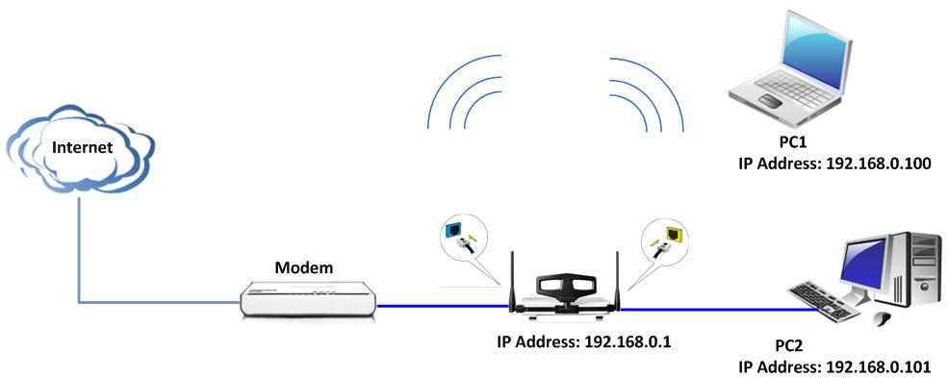

The Steps are as below:
1．Connect the computer to the router’s yellow LAN port with Ethernet cable and login to the router’s home page.
2．After successful login to the router’s home page, please click WLAN Settings→Access Control. you can find there are three option in the list.

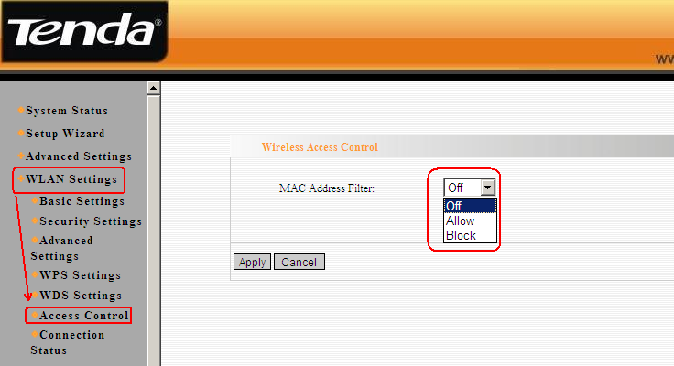

3．Please choose Block, and add the the computer’s mac address you want to prevent.(you must know the mac address of the wireless card before you do this). Then the computer with this mac address can’t connect to the wireless network.
For example, PC2 with mac address C8:3a:35:00:BC:00 and PC3 with mac address C8:3a:35:00:C8:02. We add the PC3’s mac address to the list and click Apply. Then the PC3 can’t connect to the router wirelessly, but the PC2 can connect to the wireless normally.

